Project support: Gemini Landmark Description App
Version: 1.0.0
Date: June 19, 2025
Author(s):
Kamlesh Chowdhary ( kamlesh.23bce10260@vitbhopal.ac.in )
Prashasti Joshi ( prashasti.23bce10893@vitbhopal.ac.in )
Somil Asati ( somil.23bce10364@vitbhopal.ac.in )
Devansh Tyagi ( devansh.23bce10247@vitbhopal.ac.in )

1.Introduction

1.1 Project Overview
The Gemini Landmark Description App is an AI-powered web application built with Streamlit. Its purpose is to deliver rich, descriptive information about landmarks from user-uploaded images. By leveraging Google’s Gemini Pro Vision model, the app analyze visual features in a photo and generates historical, architectural, and cultural narratives. This transforms every image into an engaging learning experience, seamlessly connecting real-world exploration with instant knowledge.
About Streamlit
Streamlit is a Python framework selected for its ability to create interactive rapidly, data-driven web apps without requiring advanced web development skills. With straightforward Python commands, developers can build user interfaces featuring file uploaders, buttons, and text displays. This streamlines prototyping and deployment, making Streamlit ideal for projects focused on AI functionality rather than complex front-end design.
About Gemini Pro Vision Model
Gemini Pro Vision is a cutting-edge multi-modal AI model from Google. “Multi-modal” means it can process and understand multiple types of input at once—in this case, both images and text. Unlike traditional models that handle only one data type, Gemini can interpret an image, identify the landmark, and use the accompanying text prompt to tailor its response to the user’s intent.
1.2 Goals and Objectives
Goal: Enhance travel, education, and exploration by providing AI-driven landmark descriptions.
Objectives:
- Create a responsive, user-friendly web interface for image uploads and multilingual output.
- Use the Gemini model to generate engaging, context-aware landmark descriptions.
- Allow output customization based on user roles, such as tourists, tour guides, educators, and enthusiasts.

What is Responsive Design?
Responsive design ensures the app’s layout automatically adapts to any device—smartphones, tablets, or desktops. This is essential, as the target audience includes travelers, educators, and guides who may access the app from a variety of devices.
1.3 Scope
The project centers on multi-modal AI inference using user-uploaded images and scenario-specific prompts. Key features include:
- Image handling and preprocessing
- Dynamic prompt selection based on user scenario
- Text generation and translation
- History tracking and download options
- Excluded from this version:
- Persistent storage
- Real-time image capture via camera
- Geolocation-based suggestions
What is Multi-modal AI Inference?
“Inference” refers to using a pre-trained AI model to make predictions or generate content, as opposed to “training,” where the model learns from data. The app performs inference by accepting both an image and a text prompt, then producing a descriptive output. It is like consulting an expert: you provide a photo and a question, and receive a tailored answer instantly.
1.4 Target Audience
- The app is designed for a wide range of users:
- Travelers seeking insights while exploring new places
- Tour guides aiming to enrich visitor experiences
- Educators creating virtual learning tools
- Architecture and history enthusiasts pursuing personal interests

2. Problem Definition and Use Cases
2.1 Problem Statement
In real-world tourism or education, individuals often come across significant landmarks without accessible, concise, or engaging historical context. Existing solutions like guidebooks or web searches are time-consuming, language-dependent, and often require prior knowledge of the landmark's name. There is a clear need for a vision-based AI tool that can process visual input and return meaningful content instantly.
2.2 Use Case Scenarios
Scenario 1: Discovering Iconic Landmarks
A traveler exploring a new city stumbles upon a majestic monument. Without needing to know its name, they upload a photograph into the app and instantly receive a well-structured description containing its name, significance, and architectural features. This elevates their sightseeing experience from passive observation to informed appreciation.
Scenario 2: Tour Guide Assistance
A professional tour guide uses the app to enhance live narration. By uploading a photograph and selecting the "Tour Guide" scenario, the app generates interesting facts, relevant anecdotes, and conversation starters. This supports the guide’s efforts to keep their audience engaged with rich storytelling.
Scenario 3: Virtual Tours and Educational Resources
Educators designing virtual museums or site tours can upload images into the app and use AI-generated descriptions as part of their content. This use case highlights the app’s value in remote learning environments, where visual and textual integration fosters better understanding of global heritage.
Scenario 4: Personal Exploration and Curiosity
Independent learners with an interest in history or architecture can use the app to explore local or international landmarks. It provides a self-guided, educational journey where users gain insights from AI without needing formal resources.

3. Generative AI Model and System Architecture
3.1 Model Selection
The application utilizes Gemini Pro Vision (gemini-2.0-flash-001) from Google’s Generative AI suite. It supports multi-modal input, specifically combining image and text to produce relevant, descriptive output.
3.2 Architecture Diagram
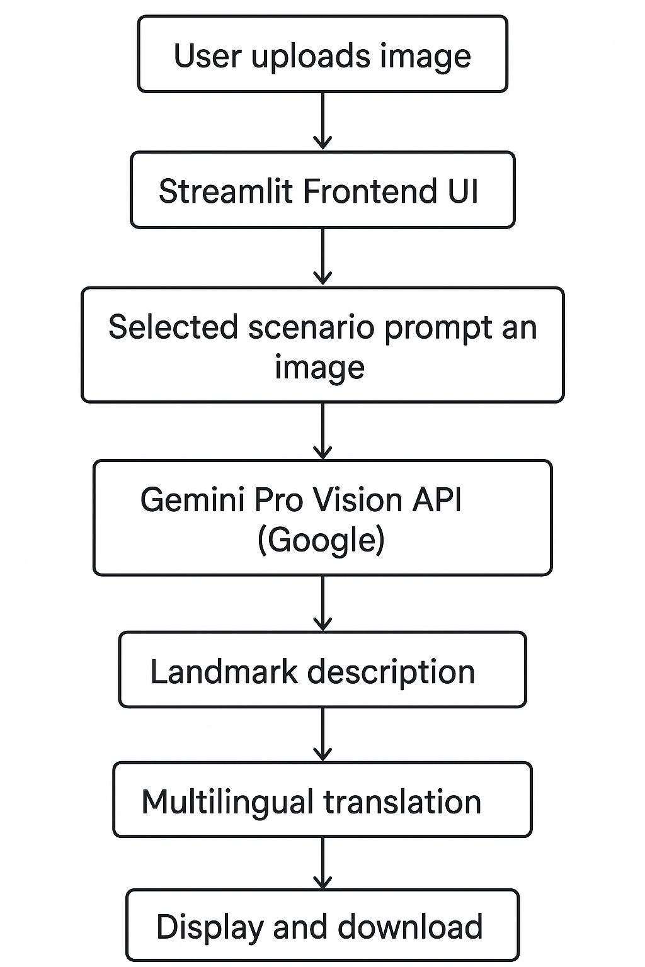
3.3 Key Components
Component | Detailed Description
Streamlit | Acts as the complete front-end and application server. It listens for user actions (like an image upload via st.file_uploader), manages the application's state, and dynamically updates the UI to display results. Its simplicity allowed us to build a fully functional prototype without a dedicated front-end team.
Gemini Model | This is the core intelligence engine. Hosted on Google's cloud, it performs the heavy lifting of visual recognition and natural language generation. Our application's quality is directly dependent on the capabilities of this pre-trained model.
PIL (Pillow) | The Python Imaging Library is a crucial utility for image preprocessing. When a user uploads a file, it exists as a raw file object. PIL was used to open this file, validate its format (JPG, PNG), and convert it into a standardized data structure (an image object or byte stream) that the Gemini API can interpret.
Googletrans | A third-party Python library that provides a simple interface to the Google Translate service. We use it to post-process the AI's output. After receiving the English description from Gemini, we pass this text to google-trans to convert it into the user's selected language.
Session State | This is Streamlit's mechanism for short-term memory. A web application is "stateless," meaning it forgets everything between interactions. st.session_state creates a temporary dictionary for each user's session, allowing us to store data like the history of generated descriptions. This data is automatically cleared when the user closes their browser tab, reinforcing our privacy-first approach.

3.4 Input/Output Specifications
Input:
- Image file (.jpg, .jpeg, .png)
- Scenario selection
- Optional text prompt
Output:
- Textual description covering name, location, history, architecture, and significance
- Translated content (optional)
- Downloadable .txt file

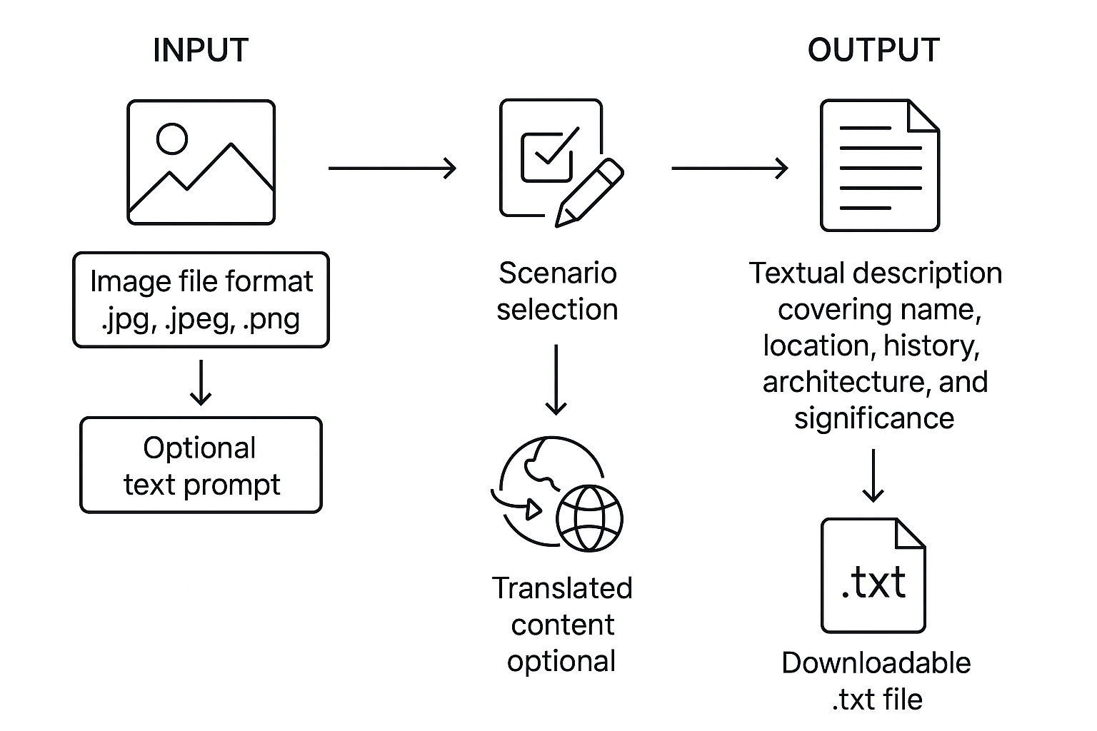

4. Data Management
4.1 Data Sources
The app does not rely on pre-collected datasets. Instead, all inputs are real-time user uploads processed during the session.
4.2 Preprocessing
- [Byte Streams]: A byte stream is a sequence of bytes representing the raw data of a file. Transmitting a file over the internet requires converting it into this universal format. Our app reads the uploaded image into memory as a byte stream, which is then embedded within the API request sent to Google.
- [Prompt Templates]: This is the core of Prompt Engineering. Instead of sending a simple user query, we use a structured template. For example, a "Tour Guide" template might be: "You are an expert tour guide. Analyze this image of a landmark and provide three fascinating, little-known facts and one engaging anecdote about it. Be enthusiastic and clear." This template constrains the AI, forcing it to adopt a specific persona and response format, leading to more consistent, relevant, and high-quality outputs.
4.3 Data Storage
- All images and descriptions are processed in memory.
- No user data is stored persistently.
- Descriptions are stored temporarily in session history for the current session.
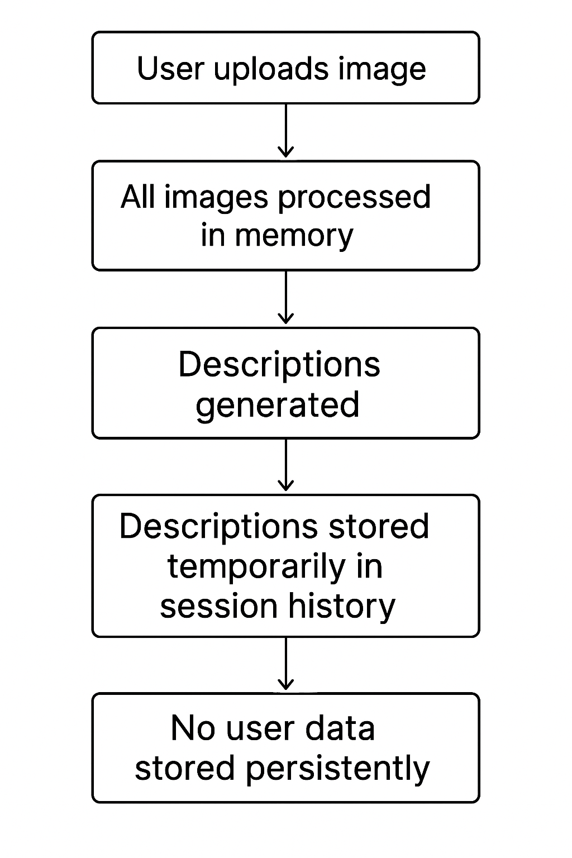

5. Training and Experimentation
5.1 Development Environment
- Python Version: 3.9+
- Libraries: streamlit, google-generativeai, Pillow, google-trans, python-dotenv
- Platform: Any OS with Python support

What is python-dotenv?
This library is a critical tool for security and configuration management. It allows us to store sensitive information, like our GOOGLE_API_KEY, in a local .env file. This file is explicitly ignored by version control systems (like Git), preventing the secret key from being accidentally uploaded to a public repository. The application loads this key at runtime, keeping our credentials secure.
5.2 Training Configuration
No model training is required. The app directly uses Google’s pre-trained model for inference.
- [Inference vs. Training]: It is crucial to understand that our app does not train or fine-tune the AI model. Training a model like Gemini requires massive datasets and enormous computational power. Instead, our application is an inference application—it solely uses the pre-existing, trained model as a service. Our development and experimentation focused on prompt engineering, not model training.
5.3 Experimentation Log
Various prompt structures and image types were tested to determine optimal response quality across the four primary scenarios.

6. Evaluation and Metrics
6.1 Qualitative Evaluation
Metric | Criteria
Relevance | Matches landmark with the correct name and context
Coherence | Structured, fluent, and grammatically correct descriptions
Detail Level | Provides depth of history, architecture, and cultural importance
Accuracy | Based on known facts of landmarks (validated manually)
User Satisfaction | Observed through test cases and exploratory usage
6.2 Findings
- High-quality outputs for known global landmarks
- Decreased precision for obscure, lesser-known images
- Translations are mostly accurate with minor exceptions in regional idioms

7. Deployment and Inference
7.1 Deployment Strategy
The app is deployed via Streamlit and is compatible with cloud platforms like:
- Streamlit Community Cloud
- Hugging Face Spaces
- Custom virtual servers (Linux/Windows)
What is Streamlit Community Cloud /Hugging Face Spaces?
These are Platform-as-a-Service (PaaS) solutions ideal for projects like ours. They automate the server setup, dependency installation, and scaling, allowing us to deploy directly from a GitHub repository with minimal configuration.
What is a Customer Virtual Server?
This is an Infrastructure-as-a-Service (IaaS) approach. It offers maximum control over the environment (OS, resources) but requires manual setup and maintenance of the server, Python environment, and security.
7.2 Inference Requirements
- Active internet connection for API access
- .env file containing a valid GOOGLE_API_KEY
7.3 Scalability
- Front-end scalability depends on host
- Gemini API scales automatically via Google infrastructure

What is Front-end scalability?
Limited by the resources of our hosting provider. Streamlit Cloud's free tier can handle a moderate number of concurrent users, but a high-traffic application would require a paid plan or a more robust custom server setup.
What is Back-end scalability?
This is a major advantage of our architecture. The Gemini API is managed by Google and is designed to handle millions of requests. Our application's usage is a tiny fraction of its capacity, so the AI back-end will never be a bottleneck.

8. Ethical Considerations and Responsible AI
Risk | Detailed Mitigation Strategy
Misinformation | This is the most significant risk of generative AI, often called "hallucination." Because the AI generates text based on statistical patterns, not a factual database, it can confidently state incorrect information. Our mitigation is two-fold: (1) Prompting: We ask the model to be factual and state when it is uncertain. (2) Disclaimers: We explicitly inform the user in the UI that the content is AI-generated and should be fact-checked for critical applications.
Cultural Biases | The Gemini model was trained on a vast corpus of text and images from the internet, which contains inherent human biases. It may describe landmarks from a pective or use stereotypical language. Our mitigation is proactive prompt engineering, where we instruct the model to provide sensitive, neutral, and respectful descriptions, avoiding subjective or offensive interpretations.
Privacy Concerns | The privacy of user-uploaded content is paramount. The primary risk involves the handling of images that may inadvertently contain personal data, such as faces of individuals in the background or EXIF data embedded in the file. Our mitigation strategy is built on a "stateless" and "ephemeral" data handling policy. No user-uploaded images or AI-generated descriptions are ever written to a disk or stored in a permanent database on our server. The entire process occurs in-memory: the user's image is held in the server's RAM only long enough to be transmitted to the Google Gemini API. Once the API returns a description, the original image data is discarded from memory. The resulting text is stored only in the user's temporary session state (st.session_state), which is automatically purged when the user closes their browser tab or the session expires. This "no data retention" policy ensures that we do not accumulate any user data, thereby ser privacy from potential breaches or misuse.
Misuse of Platform | Any platform accepting user-generated content faces the risk of misuse. This could involve users uploading inappropriate, explicit, hateful, or violent imagery, or using the tool to describe images of private individuals without their consent. Our mitigation strategy is multi-layered. First, we leverage the inherent safety filters of the Google Gemini API. These models have built-in mechanisms to detect and refuse to process content that violates safety policies, providing a robust first line of defense. Second, we employ contextual framing and user guidance. The application is explicitly designed and marketed as an educational tool for landmarks. The UI, example use cases, and pre-defined prompts all guide the user toward this intended purpose, discouraging misuse. A clear statement of acceptable use is presented to the user, prohibiting the upload of private, copyrighted, or offensive material. This combination of inherited technical safeguards from the API and deliberate application design creates a controlled environment focused on safe, educational exploration.

9. Future Work and Enhancements
9.1 Planned Improvements
- Add location services to suggest nearby landmarks
- Build a cache layer for high-frequency landmarks
- Expand language support to 25+ languages
- Integrate voice narration for visually impaired users
- Enable offline batch processing for educators
What is a cache layer?
A cache is a high-speed, temporary storage layer. By implementing a cache, if multiple users upload a picture of the Eiffel Tower, the description would be generated only once. For all subsequent requests for that image, the saved result would be served instantly from the cache. This would dramatically improve response time for popular landmarks and significantly reduce API call costs.
9.2 Research Directions
- Ground generative outputs to verified knowledge bases
- Analyze hallucination rates across languages and image types
What is hallucination?
This involves a rigorous, data-driven study to quantify the model's reliability under different conditions. The core hypothesis is that the accuracy of the AI is not uniform. For instance, a high-quality, front-facing image of a world-famous landmark is likely to yield a ate description. In contrast, an obscure local monument, a low-resolution image, or a picture taken from an unusual angle may cause the model to hallucinate more frequently. Furthermore, when translating content, nuances can be lost, and factual errors can be introduced. This research would involve creating a benchmark dataset of images and generating descriptions in multiple languages. Human evaluators would then meticulously score each statement for factual accuracy. The resulting data would provide a "hallucination rate" for different scenarios, allowing us to understand the model's limitations, provide users with a "confidence score" for descriptions, and develop better prompt strategies to mitigate errors in high-risk scenarios.

10. Version Control and Repository
Item | Detailed Description
Code Repository | [Add your GitHub/Bitbucket/GitLab link here]. A code repository is the centralized hub for the entire project. Hosted on a platform like GitHub, it does much more than just store files. It acts as the single source of truth for all code, documentation, and assets. It provides a complete, chronological history of every change ever made, who made it, and why. This is indispensable for debugging, as it allows developers to pinpoint exactly when a bug was introduced. It also serves as a collaboration platform, enabling features like issue tracking, project management, and code reviews, which are vital for a team-based project.
Branching Model | main for stable, dev for active development. This is a strategic choice for ensuring application stability. The main branch is considered sacred; it must always contain a working, tested, and deployable version of the application. It is the source from which any public release is made. The dev (development) branch is the primary workshop where all new features are built and integrated. Developers create their own feature branches off dev, work in isolation, and then merge their completed work back into dev. Only after a feature is thoroughly tested and deemed stable in the dev branch is it merged into main. This model prevents a single developer's experimental or broken code from affecting the stable version of the app.
Current Version | v1.0.0. We use Semantic Versioning (SemVer), a standard format (MAJOR.MINOR.PATCH) that communicates the nature of changes between releases. v1.0.0 signifies the first official, stable release of the application. Subsequent updates will follow this convention: A patch release (e.g., v1.0.1) would indicate a backward-compatible bug fix. A minor release (e.g., v1.1.0) would introduce new, backward-compatible functionality (like adding a new language). A major release (e.g., v2.0.0) would signify significant changes that might break compatibility with previous versions (e.g., a complete UI overhaul or changing the core AI model).

11. How to Use / Getting Started
11.1 Folder Structure
gemini-landmark-app/ ├── app.py # The heart of the application. This Python script contains all the Streamlit code for the UI and the logic for calling the Gemini API.
├── .env # The secure vault. This file stores sensitive credentials like the GOOGLE_API_KEY. It is intentionally kept separate from the source code and listed in .gitignore to prevent it from ever being committed to the public repository.
├── requirements.txt # The project's shopping list. This text file lists all the external Python libraries (e.g., streamlit, google-generativeai) that the project depends on to run.
└── README.md # The project's front door. This Markdown file provides a high-level overview of the project, its purpose, and instructions for setup, serving as the primary entry point for anyone new to the repository.
11.2 Setup Instructions
These commands will set up and launch the application environment.
- Clone or download the project.
  - Explanation: This step uses Git's clone command to create a complete, local copy of the remote repository on your machine. This includes not just the current files, but the entire version history.
- Create a .env file with: GOOGLE_API_KEY="your_google_api_key"
  - Explanation: This is a manual but critical security step. You must obtain your own API key from Google AI Studio and place it in this file. The app.py script is coded to securely load the key from this file without exposing it in the code itself.
- Install dependencies: pip install -r requirements.txt
  - Explanation: pip is Python's package installer. This single command reads every library listed in the requirements.txt file and automatically downloads and installs the correct versions. This ensures that your development environment perfectly matches the one used to build the app, preventing "it works on my machine" issues.
- Run the application: streamlit run app.py
  - Explanation: This command tells the Streamlit framework to execute your app.py script. Streamlit starts a lightweight local web server on your machine, runs the application, and provides a local URL (usually http://localhost:8501) that you can open in your web browser to interact with the app.

12. References and Acknowledgements
- Google Gemini API Documentation
- Streamlit Documentation
- Googletrans Python Library
- OpenAI (for best practices on generative model usage)
13. Glossary
Term | Definition
Generative AI | A class of AI models capable of creating new, original content (such as text, images, or code) based on patterns learned from existing data.
Gemini Pro Vision | Google's specific multimodal AI model, optimized to understand and process information from both images and text inputs simultaneously to generate relevant outputs.
Streamlit | A Python-based framework that simplifies the process of building and sharing interactive web applications for data science and machine learning projects.
Prompt Engineering | The art and science of carefully designing input instructions (prompts) to guide a generative AI model toward producing a desired, accurate, and high-quality output.
.env File | A standard text file used in development to store environment-specific configuration variables, especially sensitive credentials like API keys, keeping them separate from the main source code.

